EuroPython 2020

Virtual Conference Concept

Version: 2020-07-22

*In this document we are collecting ideas on running an online version of EuroPython and building out a concept on how to implement them. We are making it available to the public in the hope that some of it is useful for other organizers as well...*

*Enjoy,*

*--*

[*EuroPython 2020 Team*](https://ep2020.europython.eu/europython/team/)

[*https://ep2020.europython.eu/*](https://ep2020.europython.eu/)

[*https://www.europython-society.org/*](https://www.europython-society.org/)

Due to the COVID-19 pandemie, we have to consider postponing EuroPython 2020. Since the venue does not have weeks available later this year, or only with huge extra costs (e.g. 100k EUR extra for the week), the only reasonable option is to postpone to next year and run something else this year.

Raquel suggested doing a smaller virtual online event. Since this is a novelty for EuroPython and the Society, this document tries to outline a concept for running such a virtual event.

**Adding to this document**

If you want to help add content to this document,  
please ask for commenting permissions.

If you want to get in touch, please write to [board@europython.eu](mailto:board@europython.eu).

**Contents:**

Resources

Brainstorming Ideas

What are other conferences doing ?

Other aspects to consider when switching the format:

Concept for EuroPython 2020

Sessions formats and how they will be run

Talks (30 and 45min slots)

Posters

Helpdesks

No training

Conference schedule

Conference attendee on-boarding flow

Conference speaker on-boarding flow

Previews of the track sessions in Discord

Conference system

Comments

Session hosting and technical support

One Webinar room per interactive track

Speaker check-in room

One virtual room per sprint team

One virtual room per help desk track

One virtual room per poster session track

Chat system

One channel per track

One channel per track breakout room

One channel per sprint team

Conference hallway channel

Real name requirement on Discord

On-boarding people to Discord

Discord Category / Channel Layout

TODOs:

Lobby

#welcome

#registration-desk

#announcements

#hallway

#jobs

Sponsor Exhibit

#<sponsorname>-room

Conference Tracks

#holygrail-talk-room (or: <keystone>-talk-room)

#brian-talk-room

#ni-talk-room

#helpdesk-room

#poster-room

Breakouts

#example-talk-channel

Attendee Rooms

#example-attendee-channel

Backstage

#speakers

#speakers-announcements

(Talkback Channels)

Admin

#organizers

#moderators

#admins

Discord Roles

admin

organizer

moderator

registration

sponsor

speaker

attendee

attendee-muted

@everyone

Applause simulation

Playing audio in Zoom

Audio only sharing in Zoom

Lightning talks

Time simulation

Sprints

Event setup

Communication

Sponsor Setups

Virtual Exhibit

Job Board

Digital Swag

Sponsor Video Ads

Sponsor Virtual Room

Sponsor Virtual Chat Room

Social Event

After Party

Conference Merchandise

Shop research

Spreadshirt

CafePress

Zazzle

RedBubble

# Resources

* [EuroPython 2020 - Online Conference Tools](https://docs.google.com/document/d/1OAVtZnxVgmkDGvSV1vEzra7m5Nfjr-81kCrustzxAek/edit#)

# Brainstorming Ideas

This is a collection of (currently) unordered ideas around a concept:

* Run a smaller event, e.g. two days online conference, with 3-4 parallel tracks.
* I guess, the format doesn’t work well for sprints or workshops, so it’s probably best to not focus too much on these in this first iteration.
* As for conference dates, we could use the same week Wed-Frid (Jul 22-24), or move to e.g. last week of August or early in September, so that we have a bit more time to prepare for the new format.
* Run the conference using an online conference tool, with a team for each track:
  + Host to run the track
  + Moderator to run the chat
  + Support person to prepare the next speaker and manage breakout sessions for people who have additional questions for the speaker
  + We can have either 500 or 1000 participants limit per session.
  + Train all three people in all three roles, so they can act as backup.
* Have breaks between the talks to better handle transition between speakers.
* Have keynotes and plenary sessions as usual -- we’d have to use a host setup which allows more people to attend
* Depending on how good the conference tool is, perhaps we can even do lightning talks.
* The costs will be a lot lower than for a regular conference (no catering), but we’d still incur costs we’d have to cover. Because of this, we should try to get sponsors for the online event and also charge a smaller amount to enable attendance and limit the number of people who can participate (the online tools limit this number).
  + We could have only two types of tickets and no pricing stages:
    - Standard to get access to all streams and the interactivity using a single account
    - Supporter at a higher price to support the EPS grants program and be allowed to share the account (e.g. for putting streams up on an office TV)
* We could still have YouTube streaming as additional service and to increase sponsor reach, but without user interaction.  
  *Turns out this is not a good idea, since it’d be difficult to communicate why people should buy tickets when they can get live access to the content for free on YouTube.*

*We can still use streaming to YouTube as a way to have a backup recording of all tracks, by making the streams private:*

* + [*https://webapps.stackexchange.com/questions/106768/can-i-host-a-private-or-unlisted-livestream-on-youtube*](https://webapps.stackexchange.com/questions/106768/can-i-host-a-private-or-unlisted-livestream-on-youtube)
  + [*https://support.google.com/youtube/answer/6273849?hl=en*](https://support.google.com/youtube/answer/6273849?hl=en)
* Sponsor options:
  + Talks intro slide and pause slide
  + Website listing
  + Job board listing
  + Recruitment session
  + Mention in the opening plenary session
  + Tooling sponsorships (conference system, chat system)
  + Virtual room or track sponsoring
  + Sponsored talks
  + We can keep everything from the Communication category of the packages
  + Virtual booths (virtual rooms run by the sponsors)
  + Sponsor chat channels (run by the sponsors)
  + Mentions in the hallway channel
  + Short video ads between talks and during breaks
  + Inserts into the virtual swag bag (which would be hosted in the user account of each user and could contain links, items we put into a ZIP file download or coupon codes)
  + Setup a virtual exhibit in form of a web page where sponsors can post links, videos and digital swag, similar to e.g. PyCon US (<https://us.pycon.org/2020/sponsors/virtualexpohall/>)
* All sessions should be recorded and then also edited to be uploaded to our YouTube channel (I suppose Gonzo Design could help with the editing and perhaps also with the streaming).
* The biggest challenge in the setup is getting speaker notebooks configured to run the talk at the scheduled time. Perhaps we could have a few “hubs” in different cities where speakers could get together on the conference days to (re)use the same setup -- subject to the usual COVID-19 restrictions. We should also run prep sessions with them to make sure everything works and problems are addressed.
* We could have companies buy “company tickets” for the event, to have multiple people in their offices join the event online with just a single ticket, e.g. via a larger screen in the office. Again, this is subject to the usual COVID-19 restrictions.
* Things we won’t need for a virtual conference:
  + Financial aid
  + Visa letters
  + Photographer
  + Attendee gift
  + T-Shirts, bags (though we could have these provided on-demand as merchandise for people to order online)
  + Conference material (printer, paper, whiteboards, etc.)
* I have no good idea for a “social event”. Some ideas from attendees:
  + Play board games together and online: <https://en.boardgamearena.com/>
* Hallway track: We could try to arrange a chat platform (e.g. using [Discord](https://discordapp.com/)), where attendees can meet, chat and also create small chat rooms to perhaps discuss things as they normally would at a conference.
* As this is clearly a special edition if we were to do this, we should perhaps run it a bit specially, with more engagement from the community to create a sense of solidarity. So maybe have people submit photos of themselves enjoying the digital conference. And if the virus situation gets better, attendees from the same cities can get together and have many self-organised mini social events.
* Some people are suggesting to have pre-recorded talks and then focus on Q&A and chat for the event.   
  *Marc: My experience with such pre-recorded talks is rather poor. It removes a lot of excitement when doing something live and at the same time you constantly think: hmm, I should probably edit this out again / redo this section, which in the end makes the session appear a lot less spontaneous compared to a live talk.*
* To add interactivity, we could add more elements to the conference, e.g.
  + Games
  + Challenges
  + A [PyWeek](https://pyweek.org/) competition
  + Virtual helpdesks
  + A separate room for questions after a talk
  + Maybe a daily coding challenge - could give people more to talk about
  + Perhaps more panel discussions for talks
  + Chatroulette to simulate the hallways track
  + If we can have some high profile speakers, maybe host some AMA (ask me anything) sessions either by chats or videos
  + Run coffee/lunch breaks using a VR style setup using e.g. [Online Town](https://theonline.town/) or [Sococo](https://www.sococo.com/)
  + Add guided virtual sightseeing tours based on online exhibits around the world, e.g. touring the [Uffizi online exhibition](https://www.uffizi.it/en/online-exhibitions)
  + Run a Python Dojo on the sprint days, similar to what [London Python Dojo](https://mail.python.org/pipermail/python-uk/2020-April/004786.html) is doing, but perhaps with added Jitsi rooms for more work-together feeling
  + Try some of these remote team building ideas: <https://museumhack.com/virtual-team-building-for-remote-teams/>
* We could have attendees send in a photo, which we'd then arrange as a group photo after the conference.

## What are other conferences doing ?

Some conference have already switched to virtual and we could copy some ideas:

* EmberConf: <https://emberconf.com/#/emberconf-update-march-12>; they introduced “virtual swag”: <https://emberconf.com/#/streamer-swag>, powered by <https://devswag.com/>   
  They used this for interaction: <https://meet.ps/#features>
* SatRDay guide to switching to a virtual conference: <https://docs.google.com/document/d/1ZXmwVibQKtfCY_HiB49-OhQL-yKhUS9YD9yeMQZH88E/edit#heading=h.j59zs7742w39>  
  They used Zoom Webinar accounts and Slack for the conference.
* The FSF streamed their LibrePlanet 2020 conference live using tools such as Jitsi, Icecast and IRC: <https://www.fsf.org/blogs/community/libreplanet-day-1-can-free-software-carry-an-entire-online-conference-yes-it-can>  
  We could use such combinations as well, but should really try to find an easier to use solution, since we don’t have as many volunteers available.
* [Open Hardware Summit 2020](https://2020.oshwa.org/) switched to virtual for their event:

<https://2020.oshwa.org/2020/03/08/the-2020-open-hardware-summit-is-going-virtual/>

Here’s a [screenshot](https://twitter.com/llanga/status/1238494931355828224?s=21) of the setup they used:

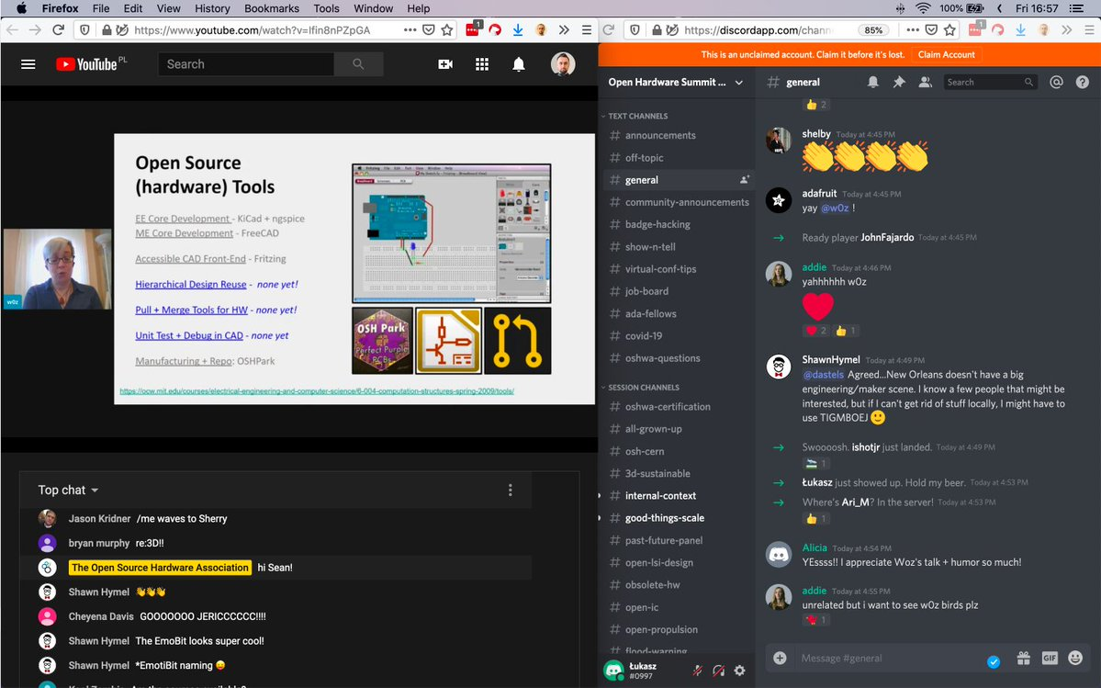

On the left you see YouTube streaming with chat. On the right, a Discord server for more chat channels.

## Other aspects to consider when switching the format:

* The venue will keep the money we have already paid as “reservation” fee.
* We will have to have a tax advisor file VAT in Ireland to get the venue invoice VAT back. The advisor will also have to file NUL-filings for the next few quarters.
* We’ll have to inform vendors we were in contact with:
  + Interflow (logistics) -- done
  + Total Expo (booths) -- done
* We need to ask Attendify to “move” the conference app to next year, unless we want to continue using it for the virtual conference. -- done
* We should have a new logo for the virtual event.

# Concept for EuroPython 2020

Based on the above ideas, we will use the following concept to run EuroPython 2020 online.

## Sessions formats and how they will be run

### Talks (30 and 45min slots)

Talks will be run in multiple parallel tracks (initially 3 tracks, could be more if we find more volunteers).

There should be 5 minute breaks between talks to assure smooth transition from one speaker to the next.

### Posters

Posters are normally displayed as printed PDFs in A0 format at the in-person event. Speakers then present the posters in the poster sessions, so they work a lot like an interactive talk:

[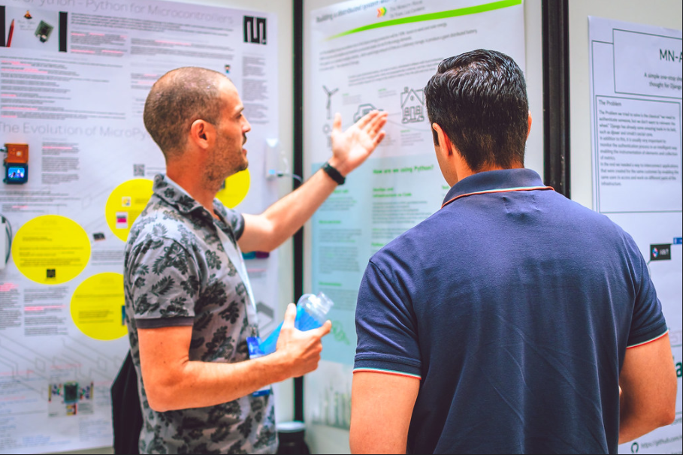](https://www.flickr.com/photos/photogenicgreen/35880962515/in/pool-europython17/)

For the online version, we will have to emulate this in a similar way, i.e. display JPGs previews of the posters on a web page, which then link to the PDF versions for closer inspection.

We will need to create a gallery web page of posters with links to the PDF files for attendees to view and download.

The interactive parts can then be arranged by using breakout rooms for each poster during the poster session, with the links to the breakout rooms added to the gallery page.

### Helpdesks

Helpdesks sessions offer open source projects to provide on-site help to attendees for certain topics. People suggesting a helpdesk will then be available during the slots to answer questions, help with specific problems an attendee may have with a system or topic:

[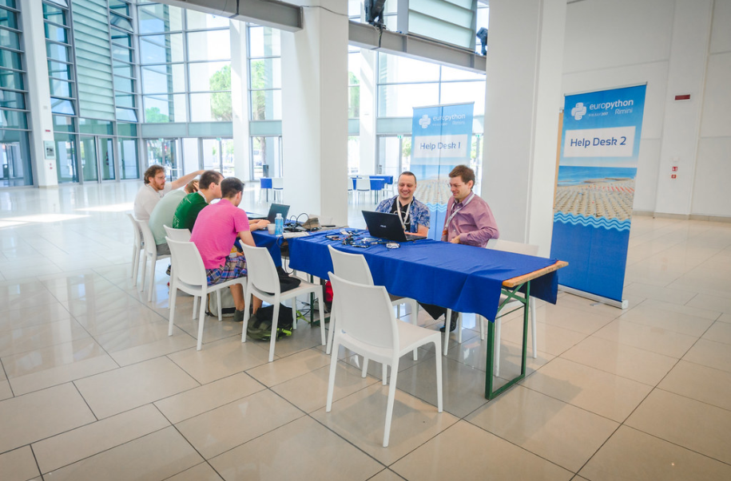](https://www.flickr.com/photos/photogenicgreen/35046952833/in/pool-europython17/)

For the online version, these can be run by setting up dedicated rooms for the helpdesk tracks and then pass over host control to the people running the sessions.

We won’t need to actively maintain them, except for managing passing over control to the next person or team.

### No training

We won’t have enough resources to run training sessions.

## Conference schedule

We have started drafting up a possible schedule for the conference:

* <https://docs.google.com/spreadsheets/d/1DNgN02Os24m0U5vP9z2eypAtVL7kaqkpYjoxBGm1lmI/edit#gid=1317360607>

## Conference attendee on-boarding flow

This is the flow we could use for attendee on-boarding:

1. Attendees buy a ticket and get a ticket ID
2. We send the attendees invite links to the Discord server and explain a little that they will need to create an account on Discord and that they will be able to access the Zoom sessions from the links on Discord. They should do this before the conference, not on day one of the conference.
3. Attendees then go to the Discord server and get welcomed in the #registration-desk channel (we have setup Discord to only make this one channel visible for unregistered people). They then enter their name and ticket ID into the chat, a registration agent then checks these against the database and if all is good, changes their nickname to the real name (first name + last name), since we want to simplify attendee interaction and promotes them to the attendee or speaker role. The registration agent should react to the attendee message using an emoji to signal “I’m dealing with this person” and avoid duplicate work.
4. As attendee/speaker they can then see all the other channels and get access to the Zoom sessions via links in the channels.
5. When an attendee wants to join a track session, they’d open the track room, click on the Zoom link at the top and a new tab opens with the session in their browser. They can continue to use Discord in the other tab or use two separate windows side-by-side.

**Idea: Create a short video to walk new registrants through the process, how to use Discord and Zoom.**

## Conference speaker on-boarding flow

Same steps as above, but in addition:

1. Checking them on discord as @speaker role.
2. Provide them a document with requirements (zoom version, suggested internet connection, etc)
3. Coordinate a rehearsal date with them to test and to check if they have questions.

### Previews of the track sessions in Discord

We can also try to provide live previews of the Zoom sessions in Discord by streaming the Zoom sessions to voice channels in Discord.

Alternatively, we could send screenshots of sessions to the various talk rooms and perhaps the hallway as well.

## Conference system

For session presentations using audio and video, we will use an online conference system:

* Zoom + Zoom Webinar during the conference
* Jitsi on the sprint days

Our goal is to make the system easy to use, have useful features to make the attendee experience more engaging and allow for recording and possibly streaming the talks to YouTube, so that we can have cut talk videos after the conference.

#### Comments

We are going to use Zoom for the video part and Discord as the chat system for EuroPython 2020. Zoom chat will be disabled, since it doesn’t offer any moderation tools.

GotoWebinar was the alternative, but our tests showed several problems with using it on various platforms and the management interfaces are not well laid out. Zoom has the privacy issues, but better interfaces and is cheaper/more flexible as well.

### Session hosting and technical support

Detail: TBD… two people per track, one session chair, one room manager, invite session managers, create more guest feature feeling, etc.

***Idea:***

Room manager: make sure everything runs according to plan and pretty much the people responsible for the track. This can include the following: start the Zoom sessions, run recordings, monitor Q&A and chats on Discord, coordinate speakers' pre-talk tests, talk-back to speakers for any A/V issue, play sponsor ads. Room managers should be the core media-WG with in-depth knowledge of the workings of the Zoom and Discord and the conference's workflow.

Session chairs: a host of specific sessions. They make guest appearances, having previously been trained to use Zoom, the talk-back feature of Discord and the basics conference workflow. They should be comfortable (and even enjoy) talking and making jokes in public. Ideally, they are somewhat known figures in the community.

### One Webinar room per interactive track

These will be used for presentations. A chat channel will be associated with the room to allow for text based feedback.

One of the rooms will have to have full capacity to take on all attendees for plenary sessions.

Initially, we are planning to have 3 such tracks run in parallel. We can add more, if we find more volunteers.

These rooms will be recorded using the Zoom cloud recording feature and perhaps also on YouTube. It may also be possible for the co-host to record locally as extra backup.

**Question: We could additionally stream the talks to an unlisted YouTube stream and then make this link available as well. This allows for more options on the attendee side, since YT streams support scrolling back in time, display on TVs, etc.**

### Speaker check-in room

A single room intended to provide a place to check speakers' setup: Test the audio, share-screen, video quality, etc. before their talk.

Speakers sometimes have problems with setting up the sharing. Issues we have seen so far:

* Sharing not working at all (black screen shared)
* Cut off screens (notably on the right side)
* Low resolution shares causing the shared content to not fill the Zoom window
* Other windows covering the shared one, causing black rectangles to appear on the shared stream.

Ideally, speakers should share FullHD content on a second desktop (can be virtual) and use a larger font size. Sharing windows only often leads to problems.

### One virtual room per sprint team

On the sprint days, we can set up [Jitsi rooms](https://meet.jit.si/) for each sprint team and post their links to the sprint team Discord channels in their descriptions for easy access.

The Jitsi room should use names such as: “EP2020-{sprint-team-name}-{random-string}” to protect against unwanted visitors. The random string should be an alnum string to make enumeration attacks harder.

Using Jitsi instead of Zoom will allow us to have lots and lots of teams and rooms.

These rooms will not be recorded per default, but since Jitsi allows for YouTube streaming and recording to Dropbox, we could also arrange for that, if wanted.

**We will need to setup our own Jitsi server for this, to work around possible load issues with the public** [**https://meet.jit.si/**](https://meet.jit.si/) **one.**

### One virtual room per help desk track

These will be used for running help desks. Screen sharing can be used to explain details.

**Question: How many help desk tracks will we run in parallel ?**

*We did not have any helpdesk submissions, so probably none.*

These rooms will not be recorded.

### One virtual room per poster session track

These will be used for running poster sessions, where attendees can ask questions and the speaker can use the poster via screen sharing to explain.

In order to have multiple poster speakers present their posters, we will likely have to either set up multiple such rooms (one per poster) or use the breakout room feature of the conference system, if available.

**Question: How many posters will be presented in parallel ?**

*We currently do not have poster submissions, so probably none.*

These rooms will not be recorded.

## Chat system

In order to allow attendee interaction during the event, we will set up a Discord chat server as a chat system.

### One channel per track

This channel can be used during the track presentations for interaction. A moderator will keep an eye on the chat, since the speaker will not easily be able to follow the chat while giving the talk.

“Tracks” in this context means:

* Talk/panel/interactive room tracks
* Poster session room tracks
* Helpdesk room tracks

### One channel per track breakout room

(Optional). These channels are intended to provide a place for after-talk discussions with the speaker of the most recent talk in a track.

### One channel per sprint team

These channels are intended to provide a place for sprint team discussions and setup for each team on the sprint days.

The channel's description will link to the sprint virtual room on Jitsi.

### Conference hallway channel

This can serve as a hallway track for people to come together, initiate discussions and then take this off to other seperate or private channels.

Attendees can ask moderators to create topic channels in the attendee rooms category if they would like to have these public. Private channels would have to be managed by the attendees on other Discord servers or platforms.

### Real name requirement on Discord

In order to facilitate better interactions with people on the Discord server, we should require people to adjust the nicknames to their real names.

This can be done in Discord without losing your real nickname, since it’s a per server setting. Per default members get invites using their real nickname.

### On-boarding people to Discord

It is best practice to have people join the server via an invite and first only give them read-only access. They should first go to the registration-desk and then get approved by an organizer and receive the attendee role.

With the attendee role, they can then also write to hallway, track, breakout and attendee channels.

### Discord Category / Channel Layout

This is an outline of the categories and channels setup for the conference.

#### TODOs:

* **Find a reasonable setup for audio channels.**
* **Configure and test keybindings for Push to Talk for all moderators for the talk-back function with the speakers.**
* **Do we want to allow sending files in all channels or only a few or only by speakers / organizers ?***I think Discord allows sending links which then automatically get embedded, so we probably don’t need this for attendees, but it would be nice for sponsors and speakers.*

#### Lobby

##### #welcome

A read-only (except by organizers) channel with instructions pinned, explaining how the Zoom and Discord setup works (perhaps pointing to a web page for screenshots and more details), with special focus on the attendee setup.

##### #registration-desk

This is where all newly arrived attendees should go first (in Discord this has to be configured as the system messages channel). Only visible to users without roles, registration, moderators, and organizers.

##### #announcements

Announcements will be sent to this channel.

This is a read-only channel for everyone BUT organizers.

##### #info-room

Helpdesk room

##### #sponsors-room

Helpdesk room only for sponsors

##### #hallway

Hallway track where people can get together and then split off into an attendee room (see below).

Attendees can write into this channel.

##### #jobs

Channel for job postings.

Only sponsors should be able to post to this channel, give a short intro to the jobs and their contact details.

#### Sponsor Exhibit

Sponsor members will get the @sponsor role to clearly make them visible on Discord. Sponsor members can then get additional permissions to manage their rooms.

##### #<sponsorname>-room

Sponsor run channel. Should point to the Zoom meeting, if part of the package.

(sorted by sponsor level)

#### Conference Tracks

One channel per track, linked to the corresponding Zoom Webinars and YouTube channels in the description.

Each of these will also have an audio channel associated with them for track host / speaker communication. See below under the “Backstage” category for details.

*(probably better to use real names for the rooms, e.g. city names, Monty Python terms, planets, etc. … for now I used Monty Python names)*

##### #microsoft-track ( <keystone>-track)

Track 1 and plenary talk room.

##### #brian-track

Track 2 talk room

##### #ni-track

Track 3 talk room

#### (Track) Breakouts

Category for speaker run channels. Speakers can call the @moderator to have a room created for them to use, if one does not yet already exist.

Channels are organized into Breakout categories by track, including a separate “track” for Posters. Channel names should be kept short where possible.

Naming convention: “talk-<brief identifier>” or “poster-<brief identifier>

Moderators will need to monitor these channels as well.

##### #talk-example-channel

Example of a channel associated with a talk (impossible) named ‘Example Channel’.

#### Poster Breakouts

Breakout rooms for the poster sessions. There should be a text-based channel for each poster.

#### Sprints

Rooms for running sprints. There should be a text-based channel and a voice channel for each sprint.

Sprint Managers should be given “Manage Messages” and “Manage Webhooks” for their own sprint rooms.

Naming convention: “sprint-something-cool”

##### #sprint-hall

General conversation and questions about sprints.

##### #sprint-managers

Private chat for Sprint Managers, Organizers, and Moderators.

#### Attendee Rooms

Category for attendee-run channels. Attendees can call the @moderator to have a room created for them to use.

We should try not to have too many such channels, to keep things focused. Moderators will need to monitor these channels as well.

##### #example-attendee-channel

Example of an attendee created channel.

#### Backstage

Channels for speakers.

##### #speakers

Private channel for speakers. Speakers should be here in advance of their talk.

Roles: speakers, organizers

##### #speakers-announcements

Announcements channel for speakers.

Roles: speakers (read-only), organizers

The channel should get a message with instructions pinned, explaining how the Zoom and Discord setup works (perhaps pointing to a web page for screenshots and more details), with special focus on the speaker setup.

##### #(track)-control

Track-based organizer text chat.

##### #(track)-greenroom

Speakers and organizers can talk with voice here. This is used for final technical checks and instructions to a speaker before their talk. Speakers can join at any time, but should wait to be asked in #speakers to join this voice chat.

##### #(track)-talkback

Speakers can listen in, but only organizers can speak into these channels via push-to-talk. These allow communication with speakers during their talks. Organizers can join, but speakers must be moved into the channel from a greenroom channel by an organzer.

#### Administration

Administration channels. These should not be readable by regular attendees.

##### #organizers

Private channel for organizers only. This is also the place where session chairs and the room managers can coordinate and discuss any hosting issues.

Roles: organizers, admin

##### #moderators

Private channel for moderators to discuss Discord moderation issues. Someone can be granted the ability to help moderate conversations on Discord separately without automatically getting permissions for Announcements, Talkback, etc.

Roles: moderators, registration, organizers, admin

Note: CoC issues should be reported to the EuroPython CoC team and not handled here.

##### #admins

Channel for the server admins, maintaining the Discord server.

Roles: admin, organizers

### Discord Roles

Discord allows setting fine grained permissions based on roles. Roles are ADDITIVE, so people will need multiple roles to gain the necessary privileges.

#### admin

Administrators of the server. Can manage server itself and all roles.

Color: yellow

#### organizer

Conference organizers. Can post to #announcements and speak into talkback channels. Full moderation abilities. (Should be given @moderator tag as well, for ease of contact.)

Color: yellow

#### moderator

Can assign, move, kick, ban, and mute users, manage messages, create rooms (in most categories). Can be contacted by attendees via @moderator.

Color: red-orange

#### registration

Can assign and rename users, manage #registration-desk channel. Can be contacted by attendees via @registration.

Color: orange

#### sponsor

Sponsors of the conference.

Color: purple

#### sprint-manager

Sprint managers.

Color: teal

#### speaker

Speakers at the conference.

Color: green

#### attendee

Regular attendees of the conference. Grants reading/speaking/posting privileges to attendees.

Color: blue

#### attendee-muted

Muted attendees of the conference. This role only grants read access and can be used for mild moderation.

Color: dark blue

#### sprinter

Sprint-only attendees of the conference. Grants reading/speaking/posting privileges, but only in the Sprints and Sponsors Exhibit categories, and the #info-desk room. Can also read #announcements.

Color: blue

#### @everyone

All members of a server. New invites are automatically added to this group initially.

**Note: The @everyone nick can be used in announcements to reach out to everyone.**

Color: grey

## Applause simulation

One detail is really missing in online conferences: the audible audience feedback.

We could have some pre-recorded applause with fade-in and fade-out to be played by the host using computer audio and then streamed to Zoom.

We have to take care not to make it too loud and high pitched. Using mobiles for this often turns out to be a rather poor replacement due to the high pitch and missing bass. The existing EuroPython LT videos could serve as basis for this.

### Playing audio in Zoom

Playing the sound recording in a Webinar/Meeting is possible by sharing the computer audio. This can be done while sharing the screen, by selecting the “Share computer sound” option in Zoom:



We could even create a video snippet based on existing EuroPython videos, showing the cheering crowd, e.g. <https://www.youtube.com/watch?v=uF2GhMAaQOQ&feature=youtu.be&list=PL8uoeex94UhHFRew8gzfFJHIpRFWyY4YW&t=2810>

or  
<https://www.youtube.com/watch?v=WOKskgq1x7Y&feature=youtu.be&list=PL8uoeex94UhHFRew8gzfFJHIpRFWyY4YW&t=2252>

or

<https://www.youtube.com/watch?v=fyBvgmG-i30&feature=youtu.be&list=PL8uoeex94UhHFRew8gzfFJHIpRFWyY4YW&t=1755>

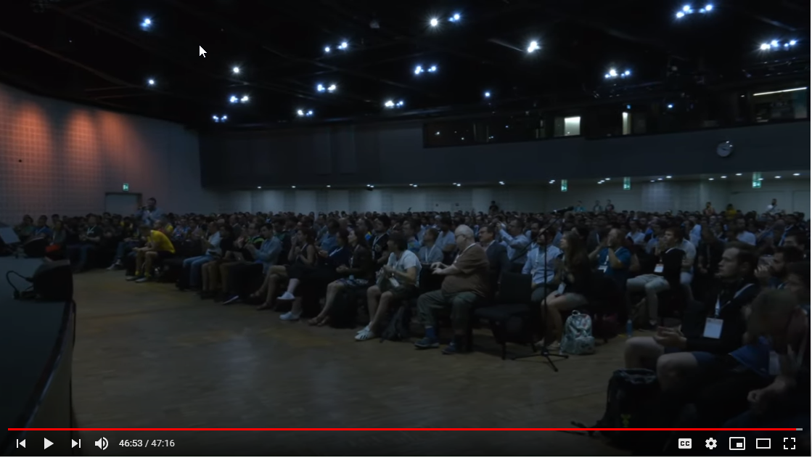

We just have to add some fade-in and -out.

When the host starts sharing the screen, the speaker’s screen share is automatically stopped, so this should be the easiest way to do this.

### Audio only sharing in Zoom

It is also possible to share only audio under the “Advanced” sharing options in Zoom:

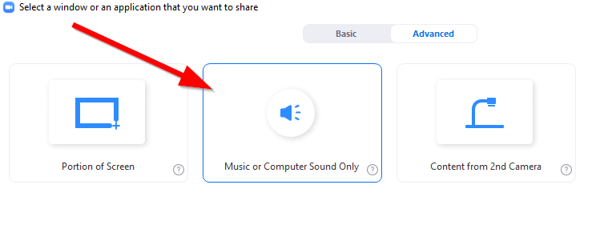

Unfortunately, the latter doesn’t work, if another participant is still sharing the screen (likely the speaker):

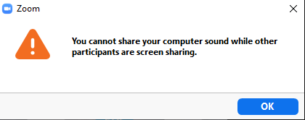

Not even when enabling the “Multiple participants can share” option:

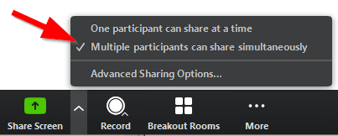

## Lightning talks

We can use a Google form for signup, which then records the entries in a Google spreadsheet. The latter will be made read-only, so that we can publish it on Discord. Changes to the entries will only be possible for people who submit their entries via their Google accounts, or by requesting the change via a moderator.

The setup is meant to avoid people cheating by editing the sheet and e.g. moving their entries further up or removing some.

LTs are then held in the order of submission, until the time of the LT slot is used up.

The link to the Google spreadsheet should be available at each track channel and moderators should announce it during breaks.

At LTs time speakers are promoted as panelist in zoom and they can share their screen.

### Time simulation

It would be nice to have some virtual way to emulate the applauses after the 5 minutes to stop the speaker.

We could have a pre-recorded audio file which simulates the finger clapping and final applause after 5 minutes. The existing EuroPython LT videos could serve as basis for this.

Sending audio to Zoom via the microphone feed of the host (using a Virtual Audio Cable) only seems to work on Linux. On Windows, the quality is too poor to be of any use.

## Sprints

### Event setup

(This is a sketch at the moment) We should have a plenary intro session in the morning, perhaps a midday session to get some feedback via text chat and another plenary at the end of each day for summaries.

### Communication

Each sprint will get a text channel on Discord and a Jitsi room setup for them on the sprint days.

## Sponsor Setups

### Virtual Exhibit

We should set up a virtual exhibit page on the website, similar to the one which PyCon US 2020 used: <https://us.pycon.org/2020/sponsors/virtualexpohall/>. This should be sorted by sponsor level.

The page will give sponsors a more permanent place to post their links, videos, coupon codes, etc.

Sponsors can, of course, also choose to only give out their swag, codes, etc. in their virtual rooms.

### Job Board

This will be run as usual on the website (see <https://ep2020.europython.eu/sponsor/job-board/>), but we will also have a “Jobs” channel on Discord.

### Digital Swag

This can one or more of these (depending on package level):

* Digital package (a ZIP file with digital content)
* PDF file
* URL + coupon codes

We can put these on a digital swag page of the website.

**Question: Should we make this page only visible for attendees ?**

### Sponsor Video Ads

These are ad video files in MP4 format and 720p or 1080p resolution, which we will show during the breaks in the talk rooms. Each video file may be up to 20 seconds long.

Sponsors get a number of slots where their ads will be shown. If a sponsor sends more than one ad file, we can distribute these across all slots they have.

### Sponsor Virtual Room

Sponsors will get a Zoom meeting room (for up to 100 or 300 people depending on sponsor level), which they can manage by themselves during the conference.

Lower sponsor levels will only get a shared room and can then use it during a time slot (one or two hours).

Sponsors are allowed to run demos, presentations, talks or even training sessions in these rooms. We will help them announce such sessions on the #announcement channel.

The virtual rooms will be available on all conference days and the sprint days.

### Sponsor Virtual Chat Room

All sponsors of Silver and up get a Discord channel assigned to them. As with the Virtual Room, they will be able to manage these chat rooms by themselves.

We will set up these channels before the conference and also link the chat room to the Zoom room via the channel description for easy access.

The chat room can be used for text feedback during presentations done in the virtual Zoom rooms.

The chat rooms will be available on all conference days and the sprint days.

## Social Event

On Thursday evening (July 23), we are planning to launch a virtual social event.

We could setup multiple rooms for smaller groups to join in activities. This could be done using Jitsi rooms or Zoom breakout session (they downside of the latter is that a host would have to assign people to the rooms).

Some ideas:

* Play online board games: <https://en.boardgamearena.com/>
* Setup a MUD style hall using [Online Town](https://theonline.town/) to facilitate hallway track chats
* Setup Discord channels linked up to [Mozilla Hubs](https://docs.google.com/document/d/1OAVtZnxVgmkDGvSV1vEzra7m5Nfjr-81kCrustzxAek/edit#heading=h.3fqq8e9i1qrp) VR scenes (up to 30 people per scene)
* Play pre-recorded music sessions or have them play live using Zoom or Discord audio (Nicholas)
* ~~Produce pre-recorded click track synchronized pieces of music (Nicholas)~~
* Run a Jason/Lais Jeopardy session

*Marc: Online Town looks a lot like a 1995 MUD game. It appears too slow for the number of people we’d have to host, but perhaps worth a try.*

## After Party

On Friday evening (July 24), we are planning to have an after show party.

We could have a DJ play music via Zoom for this and smaller breakout rooms implemented using Jitsi.

Or we could setup a VR club using [Online Town](https://theonline.town/) or [Mozilla Hubs](https://docs.google.com/document/d/1OAVtZnxVgmkDGvSV1vEzra7m5Nfjr-81kCrustzxAek/edit#heading=h.3fqq8e9i1qrp).

Other ideas:

* Run a Jason/Lais Jeopardy session

## Conference Merchandise

Depending on resources, we may be able to run merchandise shops with t-shirts and other merchandise which attendees can then buy directly.

### Shop research

#### Spreadshirt

URL: <https://www.spreadshirt.de/> and <https://www.spreadshirt.com/>

Product list: <https://www.spreadshirt.com/custom/clothing>

Seller setup: <https://www.spreadshirt.com/start-selling-shirts-C3598>

Taxation German Shop: <https://help.spreadshirt.com/hc/en-gb/articles/207194399-Taxation-of-Your-Earnings>

Taxation US Shop: <https://help.spreadshirt.com/hc/en-us/articles/207194399-Marketplace-Designer-Earnings-Taxation>

Example shop: <https://www.spreadshirt.de/user/Star+Trek+Discovery>

EU shop:

* [DE EUR prices](https://docs.google.com/spreadsheets/d/15FEooTaDTcdoU4YW3tA10eMTEXHTNKkrCwlH2kmjXC8/edit#gid=0), [DE shop terms](https://www.spreadshirt.de/partner-agb-C10183),
* [UK GBP prices](https://docs.google.com/spreadsheets/d/1GDD81f2tE31f6AKy9jSstE1qQ6XM6s96KLP3xfbQC7g/edit#gid=0), [UK shop terms](https://www.spreadshirt.co.uk/terms-C10183),
* [IE EUR prices](https://docs.google.com/spreadsheets/d/16rYykjPxUCx-wAOnvxNbUJ7uRqG7vvIFun7xn008fY8/edit#gid=0), [IE shop terms](https://www.spreadshirt.ie/terms-C10183)
* [UK + IE shipping costs](https://help.spreadshirt.com/hc/en-gb/articles/207165489-Delivery-Times-and-Delivery-Costs)
* [DE + AT + CH shipping costs](https://help.spreadshirt.com/hc/de/articles/207165489-Lieferzeit-Versandkosten)

Serve Europe, USA and Australia, using different shop setups.

Good quality t-shirts. Also do accessories, hats, bags and cups.

The [EU shop](https://www.spreadshirt.ie/) uses German taxation and permits EU VAT reverse charging as well as honors bilateral tax agreements between countries. It does not support shipping to the US.

The EU shop allows setting up shops in different EU TLDs.

The [US shop](https://www.spreadshirt.com/) falls under US taxation, along with the mandatory withholding, making things complicated for EU based organizations.

#### CafePress

URL: <https://www.cafepress.com/>

Product templates: <https://www.cafepress.com/merchandise-info/templates>

Seller setup: <https://support.cafepress.com/hc/en-us/categories/360003097714-Seller-help>

Taxation: <https://support.cafepress.com/hc/en-us/articles/360019285474-Taxes-tax-ids-and-withholding>

Example shop: <https://www.cafepress.com/profile/artonwear>

Products: t-shirts, apparels, hats, bags, cups, houseware, posters, stickers and more.

Worldwide shipping.

US taxation applies, along with the mandatory withholding.

#### Zazzle

URL: <https://www.zazzle.com/>

Product list: <https://www.zazzle.com/custom/gifts>

Designer setup: <https://www.zazzle.com/sell/designers>

Taxation: <https://help.zazzle.com/hc/en-us/articles/360004928233-Tax-Forms-for-U-S-Citizens-and-International-Designers-Associates>

Example shop: <https://www.zazzle.com/store/special_stationery>

Custom designs shop.

Provides a platform for makers and designers, rather than just merchandise.

Products: t-shirts, apparels, hats, bags, cups, houseware, posters, stickers and more.

Worldwide shipping.

US based.

US taxation applies, along with the mandatory withholding.

#### RedBubble

URL: <https://www.redbubble.com/>

Designer setup: <https://www.redbubble.com/about/selling>

Example shop: <https://www.redbubble.com/people/theodorezirinis/shop>

Taxation: <https://help.redbubble.com/hc/en-us/articles/360000846383> and <https://help.redbubble.com/hc/en-us/articles/202270799#taxes>

Custom designs shop, with a focus on artists and designers, rather than just merchandise.

Products: t-shirts, apparels, hats, bags, cups, houseware, posters, stickers and more.

Worldwide shipping.

US based.

Only supports Paypal and bank accounts for payout. They take a lax view on taxation, essentially leaving everything to the artist.

#### Threadless

URL: <https://www.threadless.com/>

Designer setup: <https://www.threadless.com/artist-shops/signup/>

Taxation: ???

Custom designs shop, with a focus on artists and designers, rather than just merchandise.

Products: t-shirts, apparels, home decor, accessories.

Worldwide shipping.

US based.

Payout only via Paypal.

#### Printful

URL: <https://www.printful.com/>

Designer setup: <https://www.printful.com/auth/register?ref=b2b>

Taxation: <https://help.printful.com/hc/en-us/categories/360002570579-taxes-and-billing>

Products: <https://www.printful.com/merchandise-on-demand> and <https://www.printful.com/custom-products>

Custom designs and print-on-demand shop. Also provides warehouse and fulfillment services.

Products: t-shirts, apparels, home decor, accessories.

Worldwide shipping.

EU and US based. VAT registered in the UK, Latvia, Spain.

APIs and many integrations into existing shop solutions.

The taxation process appears to be somewhat complicated, since they [mix EU reverse charging with VAT they apply](https://help.printful.com/hc/en-us/articles/360014008640-How-do-I-submit-my-VAT-ID-to-Printful-). Additionally, they apply [sales taxes](https://help.printful.com/hc/en-us/articles/360014009740-Why-am-I-being-charged-tax-) for some locations in the US, [New Zealand and Australia](https://help.printful.com/hc/en-us/articles/360014068439-Why-am-I-being-charged-tax-for-orders-going-to-Australia-and-New-Zealand-).